**Modified Explanation**

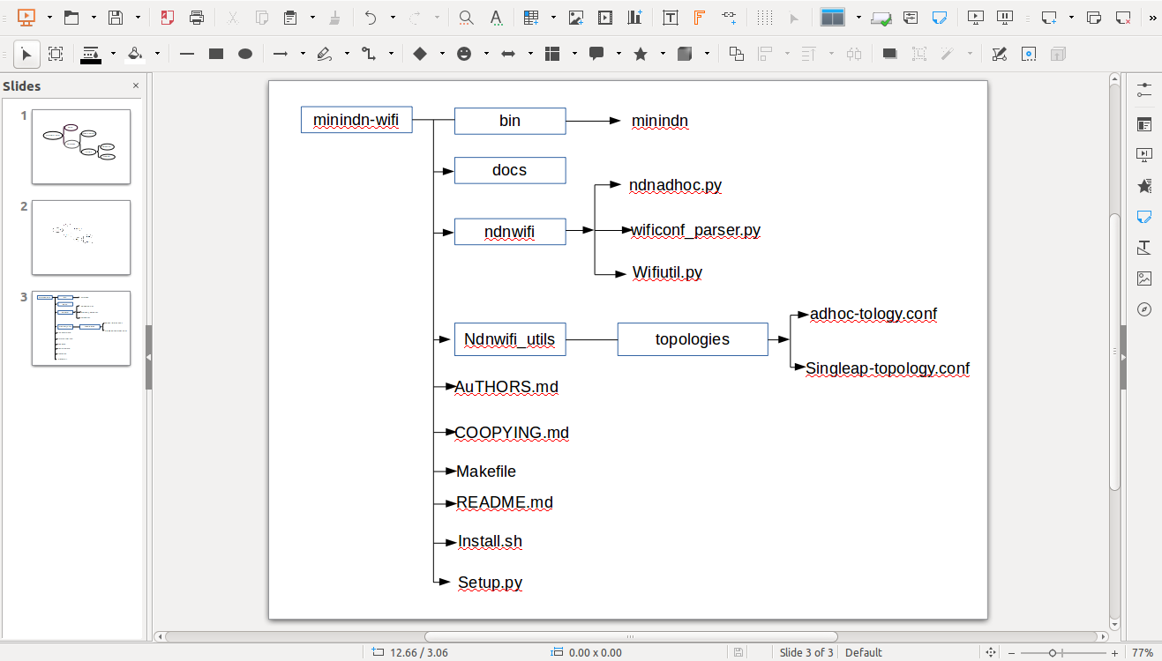

**Figure 1. The Directory Structure of Program**

1. Modified the installation file install.sh to install miniNDN-WiFi and other dependencies.

* Modified the module for installing mini-ndn
* Added a module for installing mininet-wifi
* Added a module for installing minindn-wifi

2. Added two default configure file of topology for wifi networks, and they are put in a folder ‘topologies’ under a new directory ‘ndnwifi_utils/’. When installing of miniNDN-WiFi, these files will be copied to the directory ‘/usr/local/etc/mini-ndn/wifi’

3. Copied conf_parser.py as wificonf_parser.py. Added two classes confNdnStation(), confNdnAccessPoint() and two functions parse_stations() and parse_accessPoint() in this wificonf_parser.py. And this modified file is put in a new directory ‘ndnwifi’. These classes and functions are used to create topology objects according to a configure file of topolgy.

4. Wrote a new file ndnadhoc.py and put it in new directory “ndnwifi”. This program is used to emulate ad hoc network. The function *propagationModel*() for the propagation model must be called just before the function *configureWifiNodes*() in net.py, so this method is used. The function *build_adhocnet*() in this file is similar with *buildFromTopo*() in net.py. This function is used to build net objects according to topology objects.

Encounter the main problemes:

* To emulate ad hoc communication mode, must enable wmediumd and interference .
* NFD by default treats UDP multicast and Ethernet multicast faces as broadcast. To make them recognized as ad-hoc, modify /usr/local/etc/ndn/nfd.conf and set face_system.udp.mcast_ad_hoc and face_system.ether.mcast_ad_hoc keys to “yes”.

5. Copied ndn/util.py as wifiutil.py, add a class *MiniNdnWifiCLI*(CLI). The class is used to display the prompt of miniNDN-WiFi.

6. Modified the file minindn. The structure of MiniNDN-WiFi is shown in Figure 2.

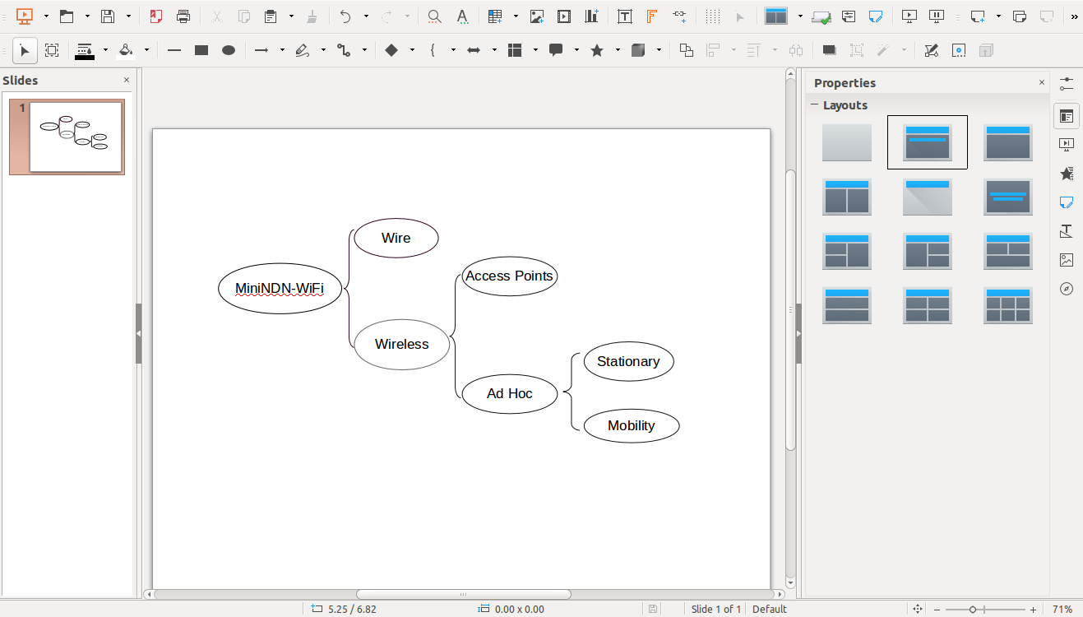

**Figure 2. The structure of MiniNDN-WiFi**

* Added a new class NdnWifiTopo() in this program. This new class is used to generate topology objects by calling the two methods parse_stations() and parse_accessPoint() in wificonf_parser.py.
* Modified the function execute() so that it can emulate wire/wireless network according user’s selecting in CLI parametes. For examples:

sudo minindn # emulate a wire network.

sudo minindn - -wifi # emulate a wifi network with AP

sudo minindn - - wifi - - adhoc # emulate a stationary ad hoc network

sudo minindn - - wifi - - manet # emulate mobile ad hoc network

This is to say, perform the corresponding module according to CLI options - -wifi/- -adhoc/- -manet.